Game is Everything

Make it nine

SHERJEEL ALI KHAN

2020

### Table of Contents

Page #

1. Introduction 2
2. Implementation 2
3. Web Links 3
4. Contact us 3

**1. Introduction**

Make it nine is mathematics puzzle game. It is created for wide range of platforms as it’s compatible with different orientations i.e. Portrait and landscape. Main scene can be found on Scene folder which has implemented the whole game. It is very simple game to play. Player needs to find two numbers whose sum is 9. But those two number must be next to each other i.e. row-wise, column-wise, diagonally as shown in the screenshots. But during game, player has to be very careful while making these matches: if player makes the match which reduce the total number of matches then they will lose. This game is created in such way to be easily customized. It allows developer to change the whole idea of the game by changing value of a variable then player has to find two numbers to make the number that you select for the variable. It can be used in video games in your game like subgame of your game which makes your game more attractive.

**2. Implementation:**

The game is ready to play. Game title and the math concept of the game can easily be changed by changing values of the variable in the script. Following are the steps to change the title and the math concept:

Step 1: Open the “Configuration” Script.

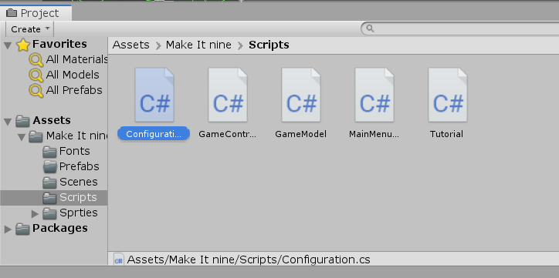

Step 2: Change “gameTitle” variable to change the title of the game and change “makeItTo” variable to change the math concept of the game.

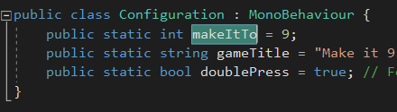

**3. Add music sound to game**

Music can be added as well by following steps:

1. Add music file to unity project.
2. Add file to the “source” variable of “Music” game object of the scene.

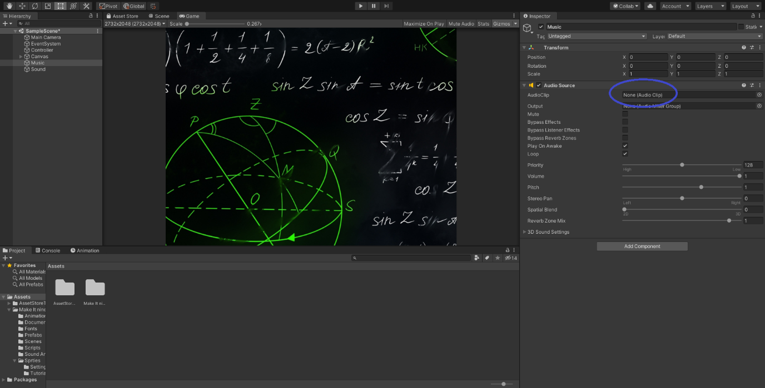

**4. Web Link**

Video links below demonstrate how the game look and how it works for different platforms.

**Make it nine (Mobile Version - Portrait)**

<https://youtu.be/CRLBvIxP6pY>

**Make it nine (Mobile Version - Landscape)**

<https://youtu.be/9P7LfaCmJGc>

**Make it nine (Windows Version)**

<https://youtu.be/Rbe_OZta3Bg>

**Game Showcase Application link:**

The application helps to demonstrate how it looks and how it works. Download game in either android or windows; and play the game. For windows unzip the file and open the game. For Android download the .apk and open it.

<https://drive.google.com/drive/folders/18vrRp5qztZ5XvDPU2hzUgmtXHERFTIlK?usp=sharing>

**Android**

<https://drive.google.com/drive/folders/11Je27e8zcPMReYzpt23S4-giF44feJTv>

**Windows**

<https://drive.google.com/drive/folders/1cgvMgVJybG1hgGZRCjT4iqWUDcNH-tBP>

**5. Contact us**

For questions, suggestions or any feedback please contact us by our email

[gie.saky@gmail.com](mailto:gie.saky@gmail.com)